# ShopNest Store Capstone Project

## Introduction

ShopNest is a prominent department store in Portugal's e-commerce landscape, committed to connecting small businesses with larger market opportunities. By providing a centralized platform, ShopNest enables merchants from various regions to effectively showcase and sell their products while taking advantage of the logistical support offered by its partners.

This capstone project seeks to analyze real commercial data related to ShopNest’s operations, concentrating on key performance metrics that can inform business decisions. Utilizing a comprehensive Power BI dashboard, this project will explore various analytical questions concerning customer behavior, product performance, seller distribution, and financial transactions. By extracting insights from the data, we aim to identify trends, opportunities, and potential growth areas, ultimately supporting ShopNest's strategic goals and operational excellence.

## Task 1: Rating Category Analysis

### Question Statement: How are orders rated by customers?

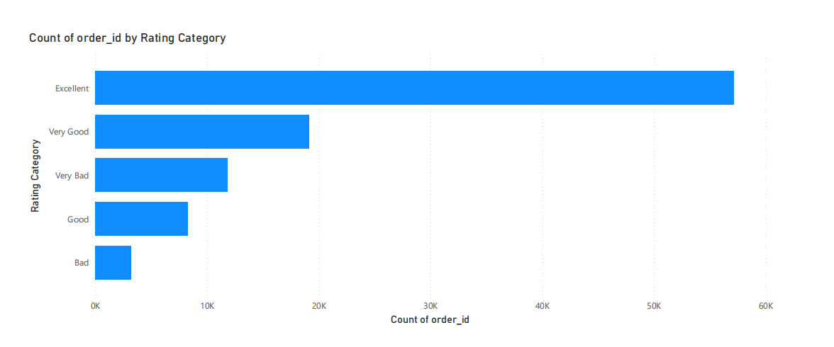

Explanation: The data shows that most of the customers gave a rating of “Excellent”, amounting to 57,168 orders. On the other hand, the category of “Very bad” received 11,827 ratings whereas “Bad” received 3,232 ratings. There were also fewer orders classified under the “Very Good” and the “Good” categories with 19,155 and 8,268 orders respectively. This points out that nearly all customers are very pleased, although the orders have a significant percentage of poor rating.

## Task 2 : Top 10 and Bottom 18 Product Categories by Orders

### Question Statement: What are the top 10 and bottom 18 product categories with respect to the number of orders received?

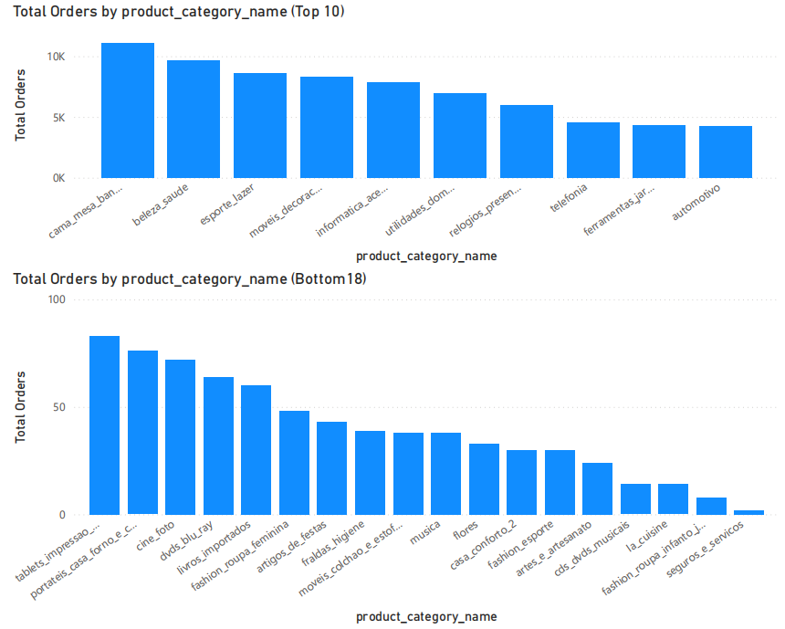

Explanation: Top 10 include Cama Mesa Banho with 11,115 orders and Beleza Saude with 9,670 orders and followed by Esporte Lazer and Moveis Decoracao. These top ten categories suggest that household and personal care products have a higher demand than other products. On the other hand, for SequrOs-seVICos and Fashion Roupa Infanto Juvenil, they had only a few orders confirming low demand for these products.  
  
The bottom 18 products by total orders reveal categories with minimal engagement, indicating either niche market appeal, strong competition, or changing consumer preferences. Categories like "SequrOs-seVICos," "fashion_roupainfanto_juvenil," and "pgamer" have very low orders (only 2 each), likely due to limited awareness or a poor market fit. Other categories such as "cds_dvds_musicals" (14 orders) and "dvds_blu_ray" (64 orders) suggest that physical media is becoming less relevant as digital streaming takes over. Likewise, home and kitchen categories like "portateis_cozinha_e_preparadores_de_alimentos" (15 orders) and "casa_conforto_2" (30 orders) may struggle against more established brands. Craft-related categories like "atese_atesanato" (24 orders) and specialty items such as "flores" (34 orders) might attract niche audiences, which limits their overall demand. Despite these lower performances, focused marketing or broadening the product range could enhance visibility and consumer interest.

## Task 3: Active Sellers by Year

### Question Statement: What was the number of active sellers each year?

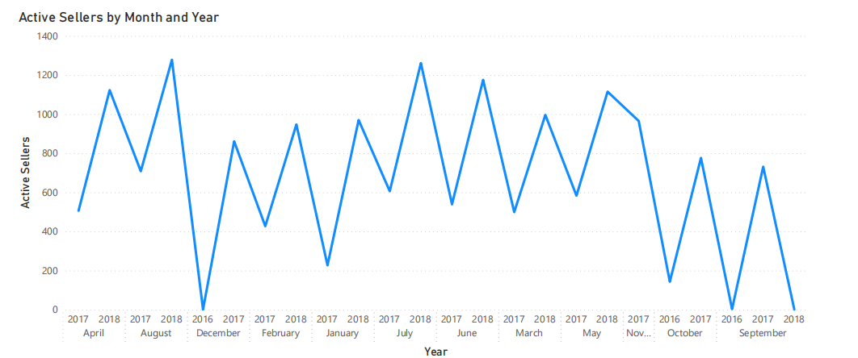

Explanation: The number of active sellers saw a notable rise from 1,784 in 2017 to 3,095 in 2018. The months with the highest seller activity were September, November, and December, indicating more sales opportunities during the holiday season. The data reflects steady growth in seller engagement, pointing to a vibrant and expanding marketplace.

## Task 4: Payment Method Distribution

### Question Statement: What is the distribution of payment methods used for orders?

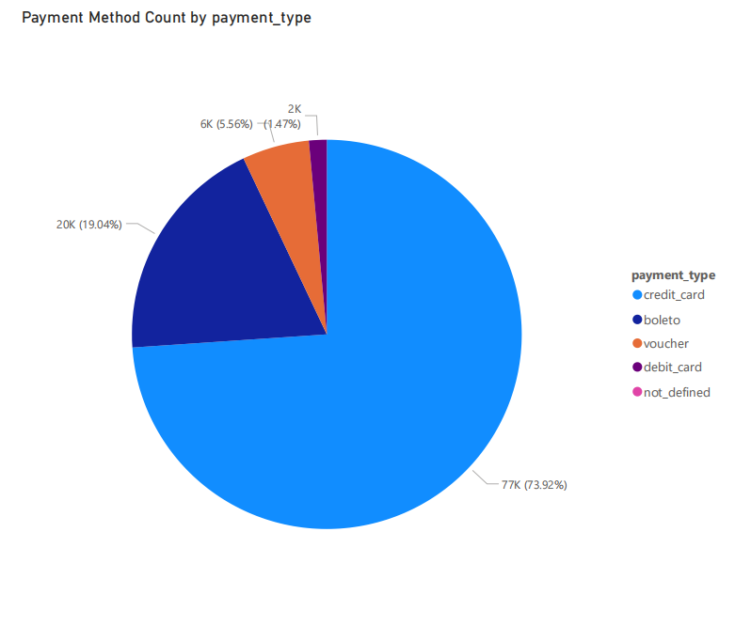

Explanation: Credit cards emerged as the leading payment method, with a total of 76,795 transactions. This was followed by "Boleto," which accounted for 19,784 transactions. Debit cards had a lower usage, with only 1,529 transactions, while vouchers were used in 5,775 transactions. This information can help in understanding customer payment preferences and in optimizing payment gateways.  
  
  
Task 5: Profit Margin by Product Category

### Question Statement: Which product categories generate the highest profit margin?

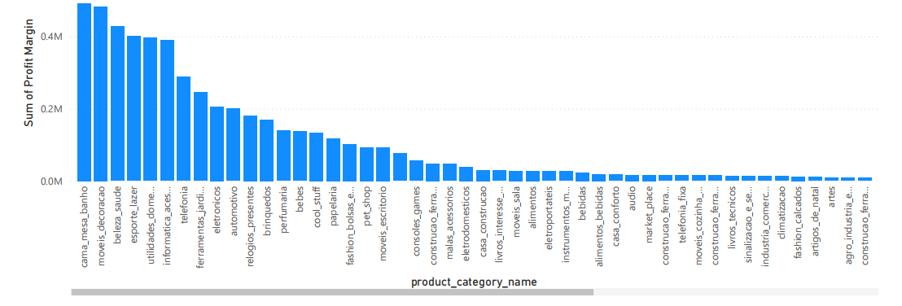

The "Cama Mesa Banho" category achieved the highest profit margin, totaling 550,336.80, while "Beleza Saude" followed with 427,929.59. Other categories like "Automotivo" and "Moveis Decoracao" also showed strong profitability. In contrast, lower-margin categories such as "SequrOs-seVICos" and "PC Gamer" contributed significantly less to the overall profits.

## Task 6: Credit Card Payment Value by Month

### Question Statement: What is the total value of payments made via credit card for each month?

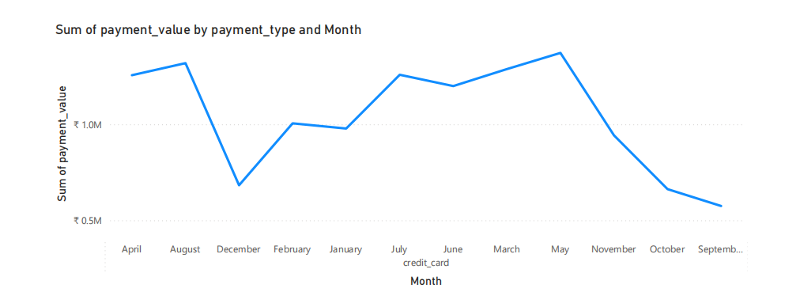

Explanation: The analysis of monthly credit card payments reveals a consistent rise in transaction values, reaching a peak of ₹1,372,603.66 in May, likely influenced by seasonal factors like holidays or special promotions. In contrast, the lowest transaction value of ₹574,736.39 was recorded in September, which may indicate a drop in consumer activity following the summer months. These patterns illustrate the fluctuations in spending throughout the year, offering valuable insights for businesses to tailor their marketing strategies and enhance sales efforts during both peak and off-peak periods. Additionally, understanding these trends can assist financial institutions in aligning their credit offerings with consumer behavior.  
  
  
  
  
  
  
  
Task 7: Seller Distribution by City and State

### Question Statement: How are sellers distributed across different cities and states?

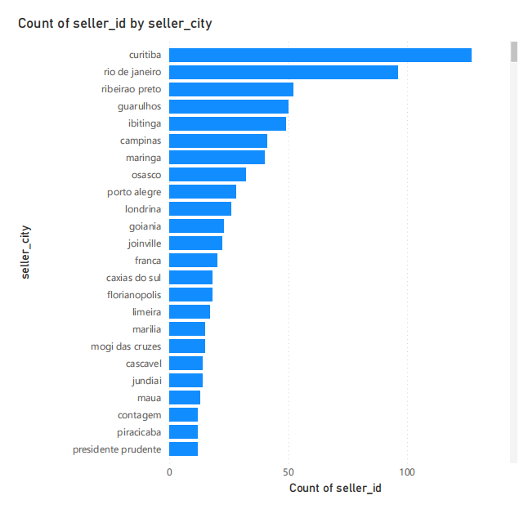  
  
Explanation: The analysis of seller distribution across cities and states shows a strong concentration in urban areas, especially in São Paulo. For instance, Campinas (SP) stands out with 41 sellers, underscoring its role as a commercial center. Close behind are Americana (SP) and Apucarana (PR), each with 10 sellers, reflecting a solid presence in these locations. A key observation is the significant number of sellers in São Paulo, which not only includes the most populated cities but also enjoys vibrant economic activity. The data indicates that smaller towns typically have fewer sellers, pointing to a trend of urban centralization. This distribution suggests that businesses in major cities like Campinas may encounter increased competition, while there are opportunities for growth in less crowded markets. Expanding seller initiatives in smaller towns could create new revenue streams and enhance market presence.

Task 8: On-Time and Delayed Orders Analysis

Question Statement: How do on-time and delayed orders trend over the period   
 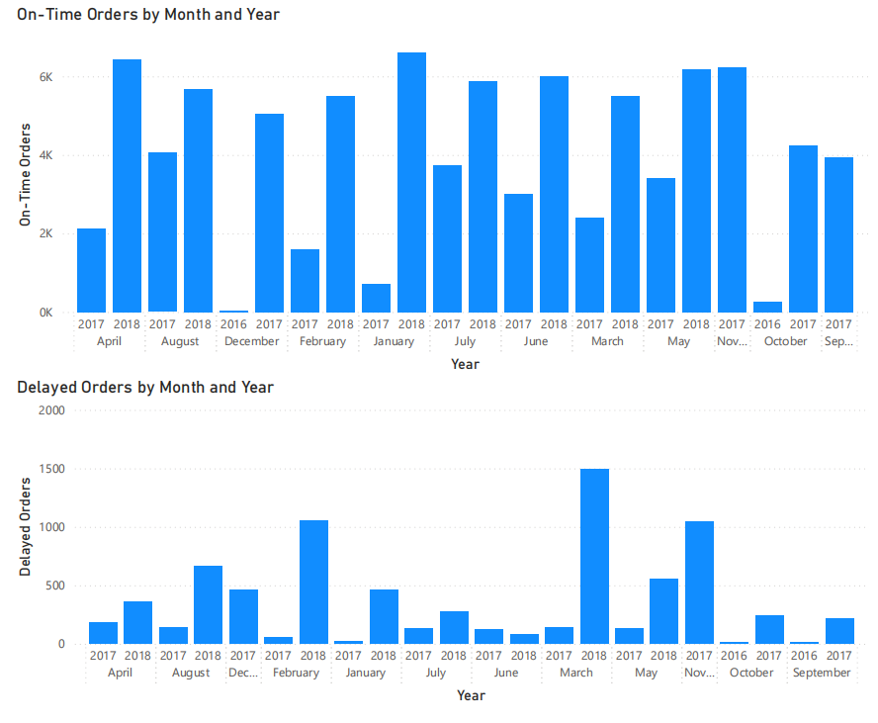

Explanation:The analysis of on-time and delayed orders from January 2016 to May 2018 reveals significant trends in order fulfillment efficiency. January 2018 recorded the highest number of on-time orders at 6,605, indicating strong operational performance, while January 2017 had a low of only 727, highlighting improvements over the year. Delayed orders peaked in March 2018 at 1,496, suggesting challenges during that period, but subsequently decreased significantly, with only 83 delays in June 2018. Seasonal patterns emerged, with higher on-time orders typically observed in early months and declines during mid-summer. Overall, 2018 demonstrated enhanced fulfillment efficiency compared to 2017, characterized by a greater number of on-time orders and fewer delays, underscoring the need for ongoing monitoring to optimize processes and improve customer satisfaction.

## Conclusion

The detailed analysis carried out through the Power BI dashboard uncovers vital insights into the operations and performance of ShopNest. The assessment of rating distributions reveals trends in customer satisfaction, with a notable share of ratings categorized as "Excellent" and "Very Good." This indicates that ShopNest is effectively meeting customer expectations, which is crucial for fostering loyalty and encouraging repeat business. Identifying the top and bottom product categories provides strategic insights into market preferences and product performance. By pinpointing the most popular categories, ShopNest can concentrate its marketing efforts and inventory management on high-demand items while also exploring the reasons behind the weaker performance of other categories.

Moreover, the analysis of active sellers by year and month highlights the platform's growth and seller engagement, suggesting the necessity for targeted initiatives to onboard and support new sellers. Insights into payment methods reveal customer preferences and could guide ShopNest’s payment processing strategies to improve user experience. Understanding profit margins by product category emphasizes the significance of pricing strategies and cost management.

Tracking monthly payments made by customers using credit cards offers a clearer view of cash flow, facilitating better financial planning. The categorization of sellers by city, while excluding specific letters, aids in shaping regional marketing strategies, enabling ShopNest to customize its initiatives based on seller distribution and potential market saturation. The dynamic visual comparing delayed and on-time orders sheds light on logistics performance, pinpointing areas for operational enhancements.

In conclusion, the data analysis performed in this capstone project not only provides a snapshot of ShopNest's current performance but also paves the way for strategic decision-making and further exploration. Potential areas for future development are also highlighted.